Guidelines for Toolbox

Index
Introduction 3
Main objectives and goals 3
Guidelines for collecting tools and criteria for inclusion of tools 5
Criteria for mapping of tools and resources 5
Criteria for final selection 7
Tutorial for searching tools in CREATE ToolBox 8
How to access CREATE ToolBox 8
Tutorial for uploading tools in CREATE OER Platform back-office 10
How to propose new tools 10

Introduction

  - The overall objective of CREATE is to enhance the performance and efficiency of Adult Education (AE) by intervening at systemic level as the nexus between overarching EU Policy (EU2020) and implementation on the ground, i.e. regions tasked with policy formulation and implementation of education programmes. The EU recognises the need to act at local level to better coordinate and plan policies, including the various sources of funding that at times may generate confusion, i.e. Erasmus+, European Social Fund and the European Regional Development Fund.
  - The CREATE Project seeks to create an EU wide toolbox for adult education policy making,
implementation, effectiveness, and financial efficiency. At present, there is no classification
taxonomy appropriate for an EU wide toolbox for adult education policy making, implementation
effectiveness, and financial efficiency. In this line, CREATE ToolBox is intended for closer alignment of adult education to economic development strategies at regional level. The toolbox aims at providing resources that could enhance policy making and implementation effectiveness. Such a resource assists in addressing the regional disparities in adult education delivery and impact across Europe.
  - In this document you will find the main guidelines to propose new tools to be integrated in CREATE ToolBox. Your submission will be reviewd and eventually approved by CREATE Consortium in order to guarantee appropriateness and usefulness of tools presented.
  - To submit new tools you will have to be part of CREATE’s Community and to do so you can either contact one of the partners of the Consortium or fill in the open submission form that you can find in the Community Section of CREATE project official website: http://www.projectcreate.eu/community.php . Your submission will be subject to approval from CREATE Consortium and your data will be included in CREATE Community and shown in the public website. To enter the Community you should provide the following: Name of your Institution, Brief description in English of your institution, Official website and logo of your institution.

Main objectives and goals

  - The CREATE Guidelines for ToolBox Repository provide orientation for associated partners, users and stakeholders to propose and include new tools and resources to manage adult education policies according to the requirements of CREATE Project - Competitive Regions and Employability of Adults Through Education.

  - By implementing these Guidelines, repository managers, associated partners of CREATE community and users in general will provide tools and resources to the Toolbox as well as gain visibility and relevance at EU Level, by incorporating their tools and resources into the CREATE OER-Platform for discoverability and utilizing value-added services provided by the CREATE portal.

Tools and resources will be presented in CREATE ToolBox and will be available to the public in the following url: http://www.projectcreate.eu/toolbox.php in its original language.

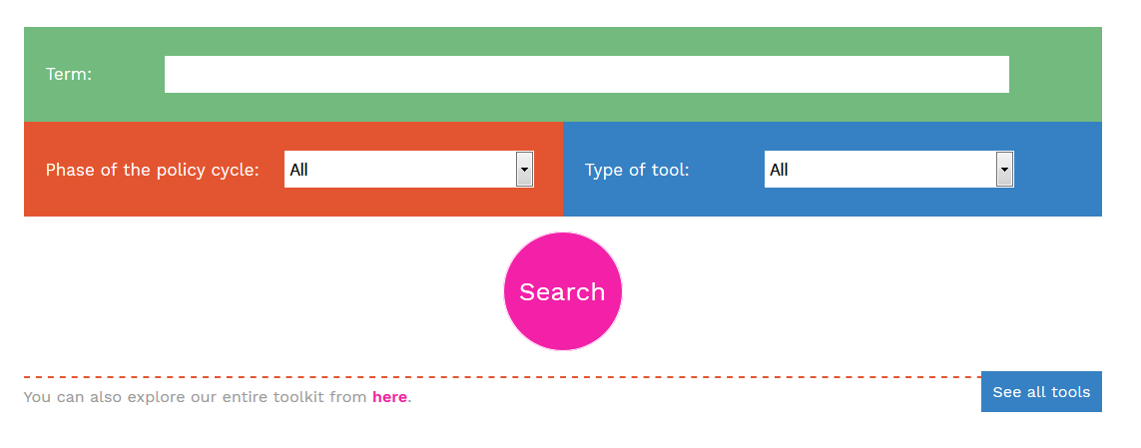

Guidelines for collecting tools and criteria for inclusion of tools

Criteria for mapping of tools and resources
For the correct identification of tools and resources to be included in the ToolBox, the following criteria shall be met. In particular:

Criteria for final selection

Once suggested tools and resources have been provided, they will undergo a strict and severe selection process performed by CREATE Consortium in order to guarantee quality and usefulness of CREATE ToolBox.

Tools will be included based on the criteria outlined before.

Please remember that the Consortium shall finally approve all proposed tools, therefore a suggestion is not an automatic addition to the ToolBox.

Tutorial for searching tools in CREATE ToolBox

How to access CREATE ToolBox

Create ToolBox is currently available online 365 days per year, 24 hours a day in seven languages namely: English, German, Czech, Latvian, Croatian, Italian and Spanish.
It will be available for the entire duration of the project and for two additional years after the end of the co-funding period that is, until October 2021.
The url to access the ToolBox is:
http://www.projectcreate.eu/toolbox.php
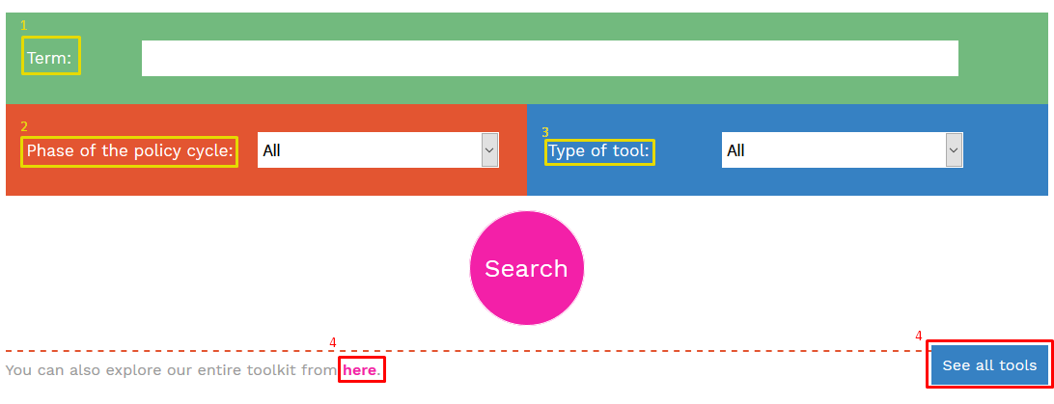
- Here you can enter a word or phrase, to look for it inside the toolbox.
- From here, you can select the policy life cycle phase in which the tool is considered useful, to be selected among the following: Evaluation, Implementation, Policy formulation, Programme planning.
- You can select the type of tool you are looking for. Choosing among: Tool (checklist, guidelines, databases), Network/forum, Case study, Best practice, Platform, Policy
- Clicking here you will see all tools, without filters.
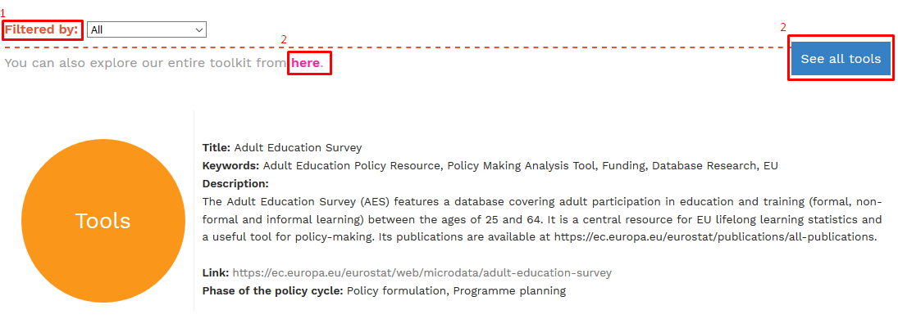
Once the search is done, you can filter it by policy life cycle phase (1) or even see all the tools without a filter (2).
In the results of your search, you can see the title, keywords, description, link or the phase of the policy cycle of tools and resources included in the ToolBox, sorted by type.

Tutorial for uploading tools in CREATE OER Platform back-office

How to propose new tools

Associated members and interested parties, apart from members of the CREATE Consortium have 2 different possibilities to propose new tools.
- Filling it the following table and sending it to the Consortium for final review of the submission

Submission Tool Table
Name of Tool
In fluent English

Description
In fluent English

Tool Title:
In fluent English

Keywords:
In fluent English

Link:
With http://

Provided by:
Name of the proposing associated partner or stakeholder

Type of Tool:  Pick one of the following | Tools (checklists, guidelines, databases)  Network/Forum  Case Study  Best Practice  Platform  Policy
Language:  English | English
Transferability:  Pick one of the following | High  Medium  Low
Up to date:  Pick one of the following | High  Medium  Low
Accessibility:  Pick one of the following | High  Medium  Low
Practical relevance:  Pick one of the following | High  Medium  Low
Description:
In fluent English
Phase of the policy cycle :  Pick one of the following  - It is possible to put the same item in different phases. | Evaluation  Implementation  Policy formulation  Programme planning

Please make sure you fill in this table in all its fields and you shall provide 1 filled in table per tool suggested.

Or

- Entering the OER-Platform back-office with the credentials provided to associated partners by the Consortium and clicking the enter button as shown, using the following url: http://www.projectcreate.eu/private/

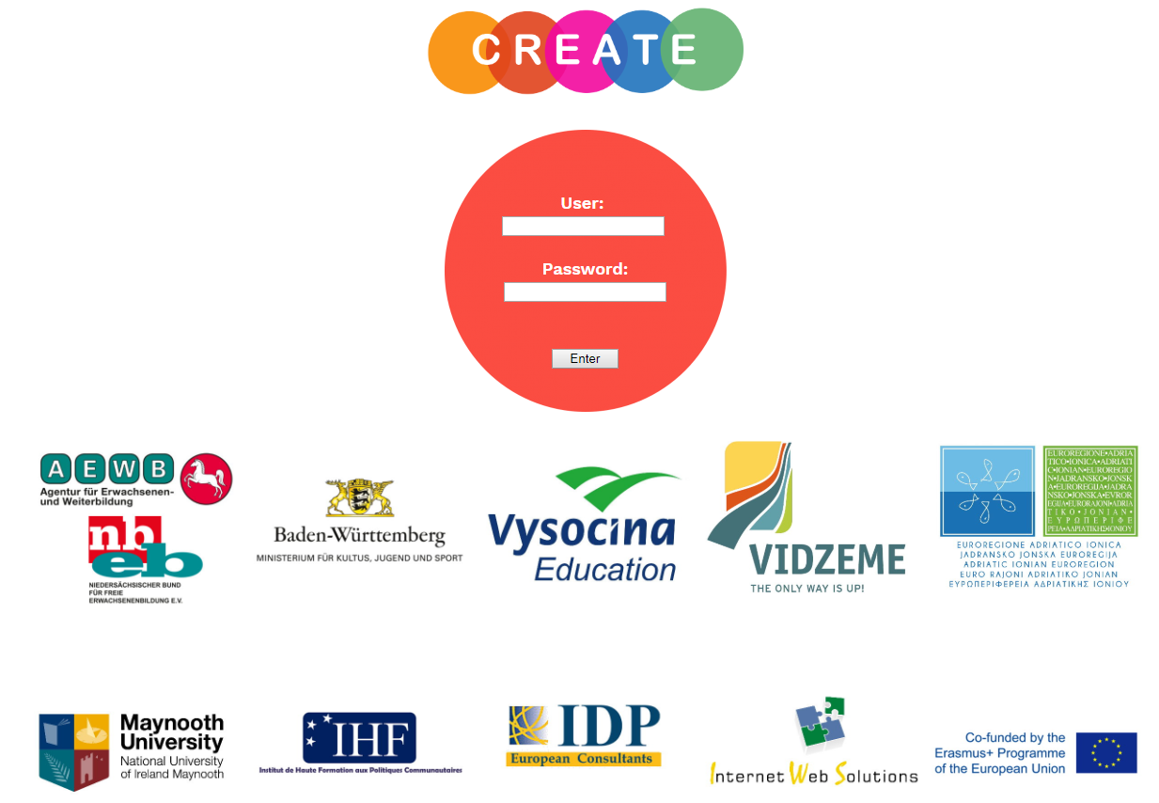

Once inside, click on "New tool"
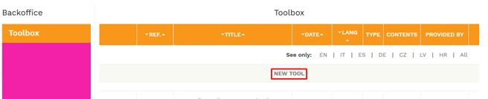
Now you just have to fill in the form with the data of the tool that you want to add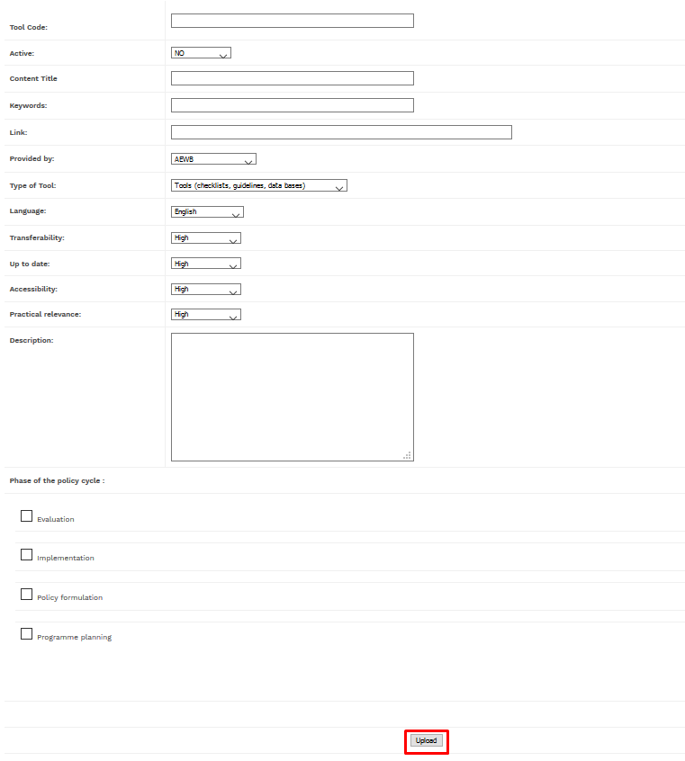
Click on Upload to send the tool for Consortium’s approval.
Your submitted tool will not be available for the public immediately, but needs to be reviewed by CREATE consortium and if it suits the requirements it will be part of CREATE Toolbox after Consortium’s approval in order to guarantee the highest quality and usefulness of the entire toolbox.

